Restoration of Columbia River Floodplain Functions to Steigerwald Lake

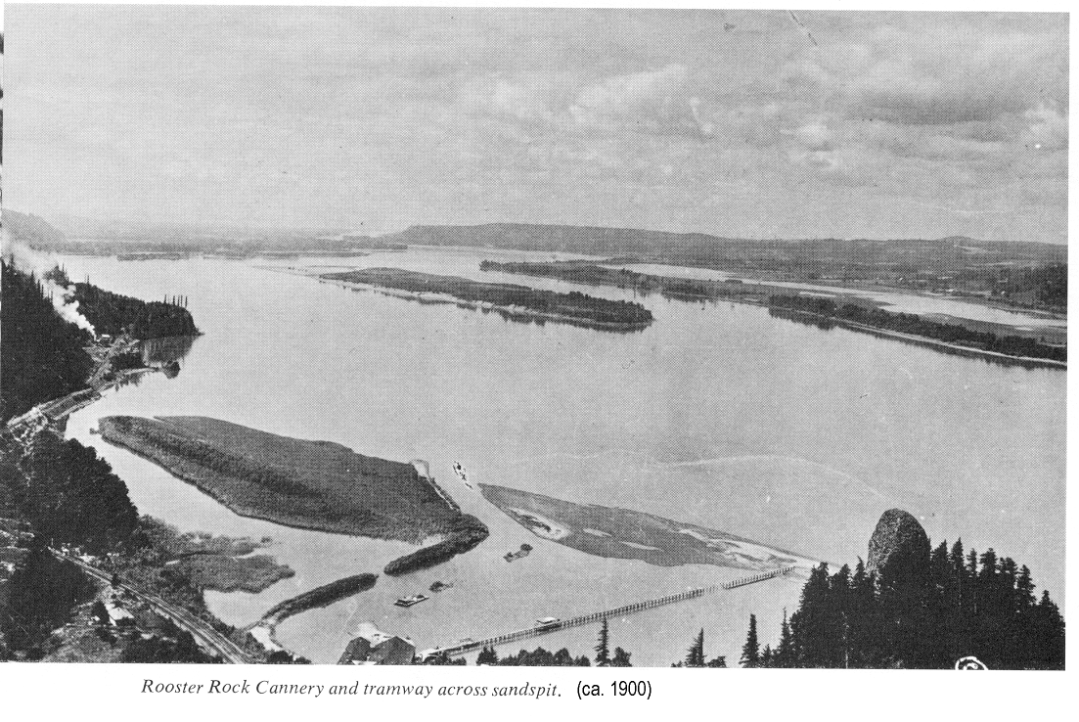

Cannery and tramway is in the foreground. Steigerwald Lake is across the Columbia River along the shoreline.

For
Bonneville Power Administration

FY 2003 Provincial Project Review

By
Ridgefield National Wildlife Refuge Complex

Ridgefield, Washington
December 12, 2001

